DOCUMENT VIEWER SYSTEM

USER’S MANUAL

Systems Development and Programming Division
Information Management Department
Revised November, 2009


Table of Contents

INTRODUCTION.................................................................................................................................... 1

LAUNCHING THE APPLICATION............................................................................................................. 1
LOGGING IN AS ODC User....................................................................................................................2
LOGGING IN AS Unit User.................................................................................................................... 7

ADDING DOCUMENT INFORMATION.....................................................................................................9

POSTING OF DOCUMENTS (for ODC)……………......................................................................................10

VIEWING OF DIGITAL FILE AND PRINTING............................................................................................11

SEARCHING POSTED DOCUMENTS.......................................................................................................11

VIEWING DISAPPROVED DOCUMENTS (for ODC).................................................................................11

LOGGING OUT......................................................................................................................................12

INTRODUCTION

The Document Viewer System is an application system developed by the Systems Development and Programming Division (SDPD) to provide a facility to add, update and browse internal and external documents of NAMRIA. It is envisioned to provide a facility for the other department of NAMRIA to be able to connect to the system and its database through the use of internet. Typically a user is asked to login their user information into the system and the application system shall display menus to input the information about a given document which shall be saved in a central web-based server.

The Document Viewer System is developed using ASP.Net and MS SQL Server as its backend.

LAUNCHING THE APPLICATION
- Open any Internet browser (e.g.,  or )). ).

- On the Address Bar, you can access the Document Viewer by typing http://app.namria.gov.ph/drims/ (see Figure 1) and press ENTER.
Figure 1

USING THE APPLICATION

- On the Document Viewer login page (see Figure 2), you are required to input the username and password provided by the System Administrator. Click button to continue.
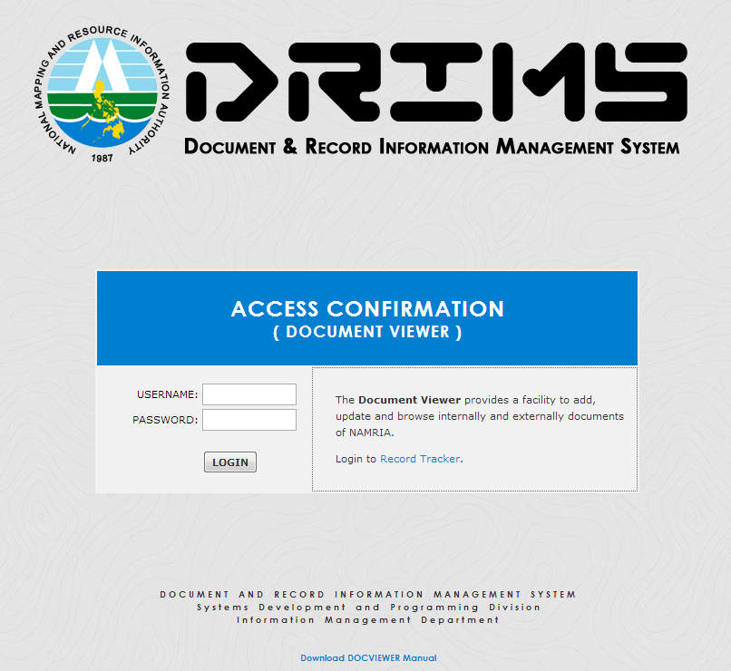

Figure 2
For ODC User
- For the ODC user, if Login is successful, it will display the Notification page (see Figure 3) if there are pending documents to be posted but if there is none; it will redirect you to the main page (see Figure 4).
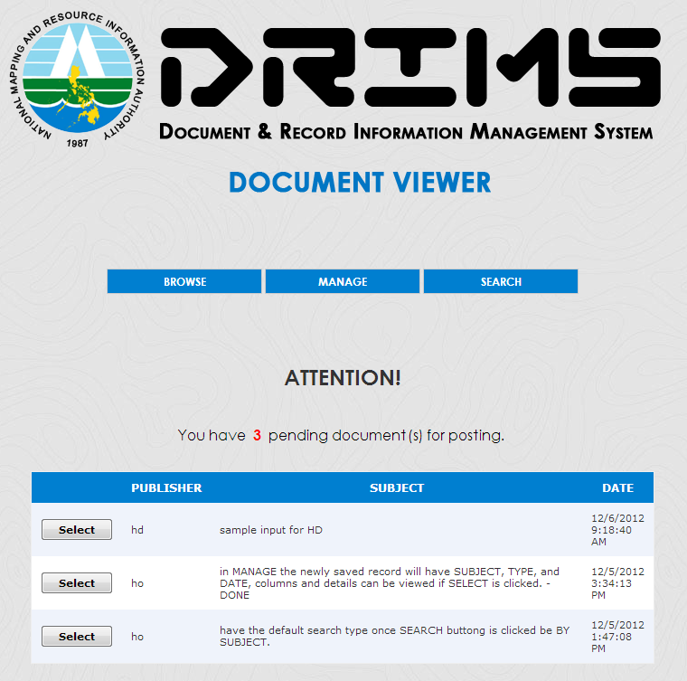

Figure 3

Parts of the User’s Main Page
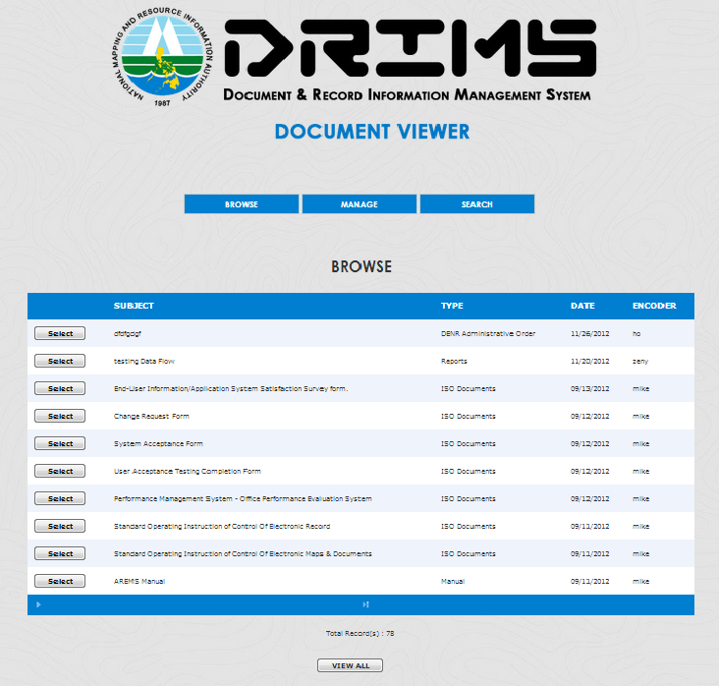
1
2
3
4
5
6

Figure 4

- When clicked, it will redirect you here in the main page
- When clicked, Document Maintenance page will be displayed (see Figure 6)
- When clicked, Search page will be displayed (see Figure 4)
- When clicked, Document Details page will be displayed (see Figure 8)
- Grid View that contains Posted Document(s)
- When clicked, the grid view will display all the Posted Documents provided with View 10 Per Page button at the bottom of the page

- When you clicked the button, the Documents page will be displayed wherein you can browse all the posted documents in the system. (see Figure 5)

Figure 5

- When you clicked the button, it will redirect you to Document Details page. (see Figure 6)
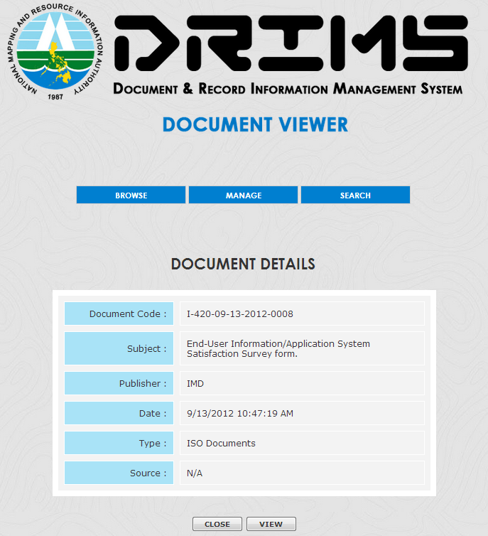

Figure 6

- When you clicked the button, it will redirect you to Document Details page. (see Figure 7)
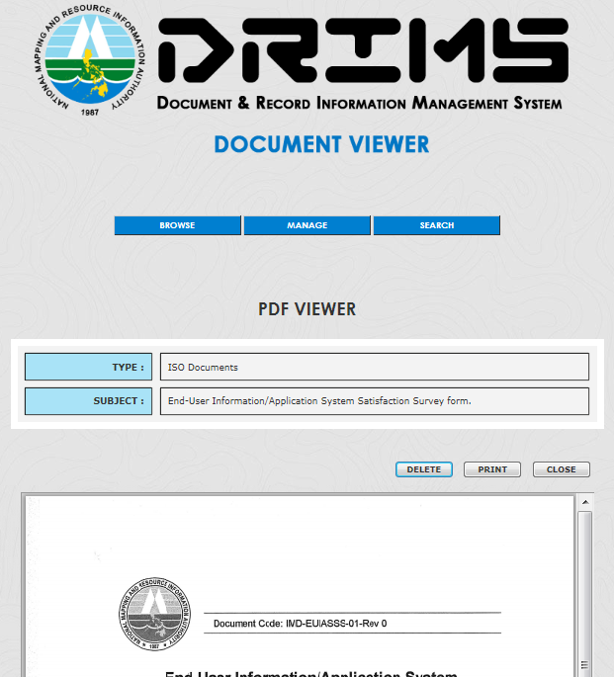

Figure 7

- When you clicked the button, the Documents Maintenance page (see Figure 8) will be displayed wherein you can add and edit a document.
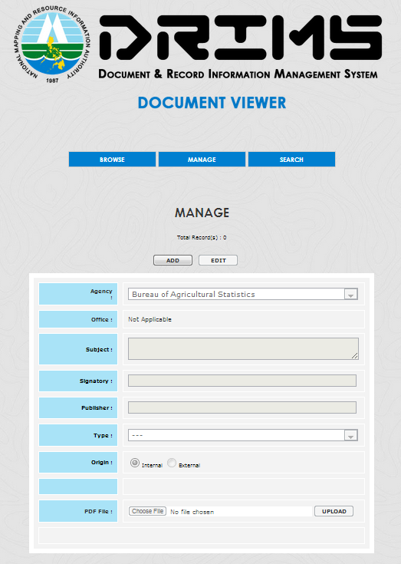
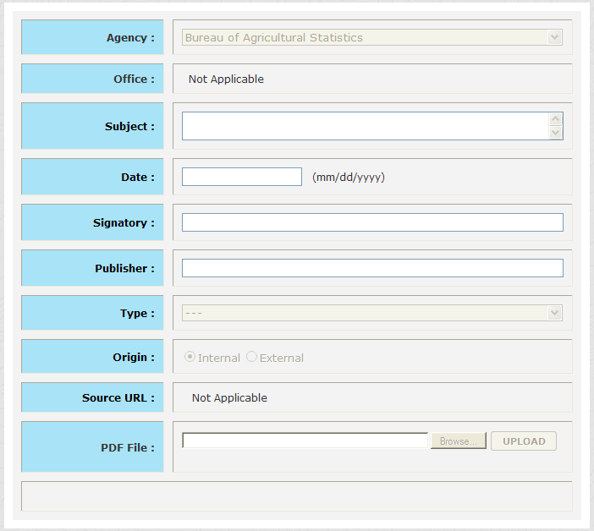

Figure 8

- When you clicked the button was clicked, the Search page will be displayed. (see Figure 9)
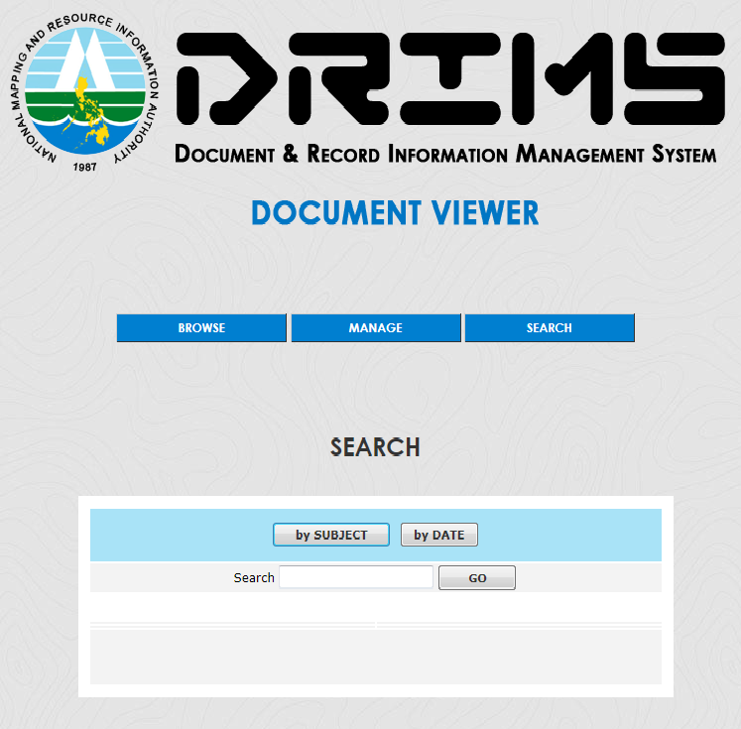

Figure 9

- When you clicked the button, the Search page will display a textbox wherein you may input the subject and clicked “GO” button to proceed with the search. (See Figure 10)

Figure 10

- When you clicked the button, the Search page will display a start date picker and an end date picker together with a “SEARCH” button to proceed with the search. (See Figure 11) You may also type the dates in the textbox following the mm/dd/yyyy format.
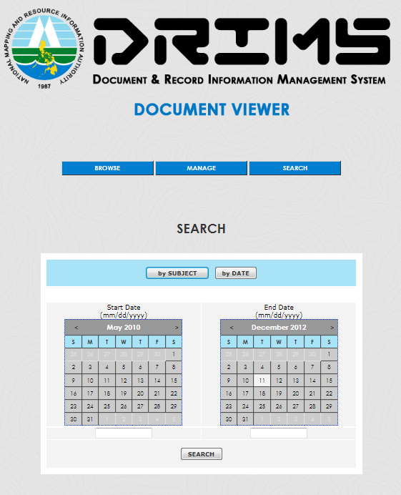

Figure 11
For Unit Clerk User
- For the Unit Clerk user, if Login is successful, the Posting Notification page (see Figure 12) will appear if there is/are denied document(s) by the Overall Document Controller (ODC) or if there are no denied documents, Approved Documents page (see Figure 13) will be displayed.
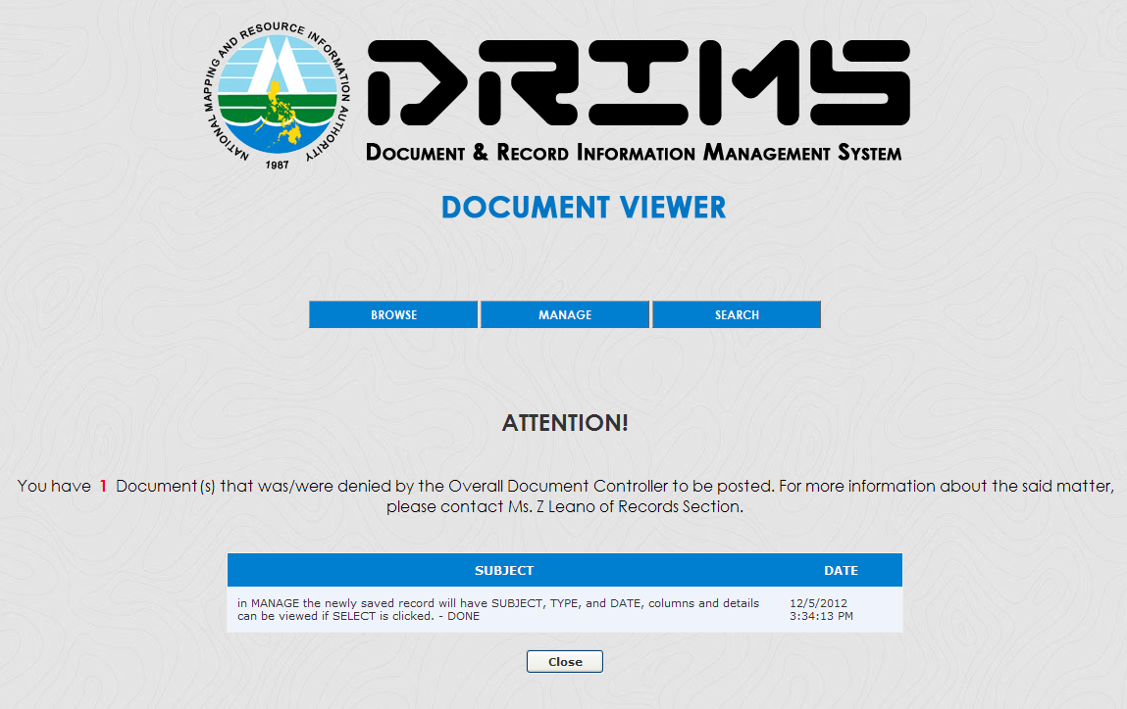

Figure 12

Figure 13

- When you clicked the button, it will redirect the user to Document Details page. (See Figure 14)

Figure 14

- When you clicked the button, it will redirect the user to PDF View page (see Figure 15)
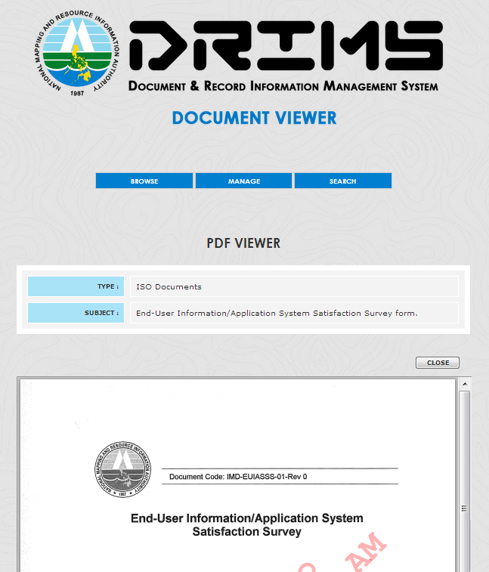

Figure 15

ADDING DOCUMENT INFORMATION
All documents need to be encoded into the Document Viewer so that all its transactions can be monitored. New documents are classified into Internal and External. To input the basic information of a document, follow this procedure:

1. To add a new document, click button.
2. Click button and start filling the information.
3. Agency. This is the agency that creates the document. (See Figure 16)

Figure 16

4. Division. This is the division of the agency that creates the document. (See Figure 17)

or

Figure 17

5. Subject. This will be the subject of the document to be created. (See Figure 18)
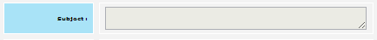

Figure 18

6. Signatory. This is the person/s who signs in the document. (See Figure 19)

or

Figure 19

7. Publisher. This is the one who publish the document to be created. (See Figure 20)

Figure 20

8. Type. This is the type of document to be created. (i.e. Administrative Order) (See Figure 21)

Figure 21

9. Origin. This is the source of the file, Internal if the PDF file will came from the computer of the user and External if it came from the internet or other government servers. (See Figure 22)

Figure 22
10. Source URL. This refers to the link of PDF file if its origin is “External”. (See Figure 23)

Figure 23

11. PDF File. This refers to the file to be uploaded if its origin is “Internal”. (See Figure 24)

Figure 24

Uploading Digital Files
- Click Browse and look for the file to be attached. This only accepts PDF Format files.
- Click Upload after selecting the PDF file.
- When done in filling the textboxes and uploading the file, click button to save the document.
***Note: When a user is an Overall Document Controller (ODC), the saved document will automatically be posted. If a user is a Unit Clerk, the saved document will go to the “Notification” page of the ODC (see Figure 3). Only the ODC user can approve the document to be posted in the system.

POSTING OF DOCUMENTS (for ODC)
Only the ODC (level 3 users) can approve and deny the document to be posted in the system.
- In the Notification page, click button to select the document to be approved and posted in the system. This will now redirect the user to the Document Details page. The pending documents to be approved can also be viewed under the menu.
- Click button if the selected document is approved to be posted in the system or button to deny the selected document and accessed it later for posting.
- After clicking the button, the document will now be posted and can be viewed in the Document Browse page. (See Figure 7)

VIEWING OF DIGITAL FILE AND PRINTING
To view and print a digital file, follow the steps below:
- Click button.
- In the Grid View, select the document to be viewed or printed by clicking the button. This will now redirect the user to the Document Details page. (See Figure 13)
- To view and print the attachment, click the button. This will now redirect the user to the PDF View page. (See Figure 14) PDF file will now be loaded and displayed in the frame and you can now print it by clicking the  icon.
- To print the document’s details, click the button.
*Note: Only the ODC user can print the details of the documents.

SEARCHING POSTED DOCUMENTS USING THE SUBJECT
- To search, click button.
- Select whether by date or by subject.
- Input the needed information in the search textbox or select the dates in the date picker or you may type it following the correct format indicated.
- In the textbox, type the keyword of the document and click or button.

VIEWING OF DISAPPROVED DOCUMENTS (for ODC)
Only the ODC (level 3 users) can approve or deny the document and accessed it later
- To view the disapproved documents, go to manage by clicking the button.
- Look for button and click it. This will now redirect you to the list of denied documents. (See Figure 25)
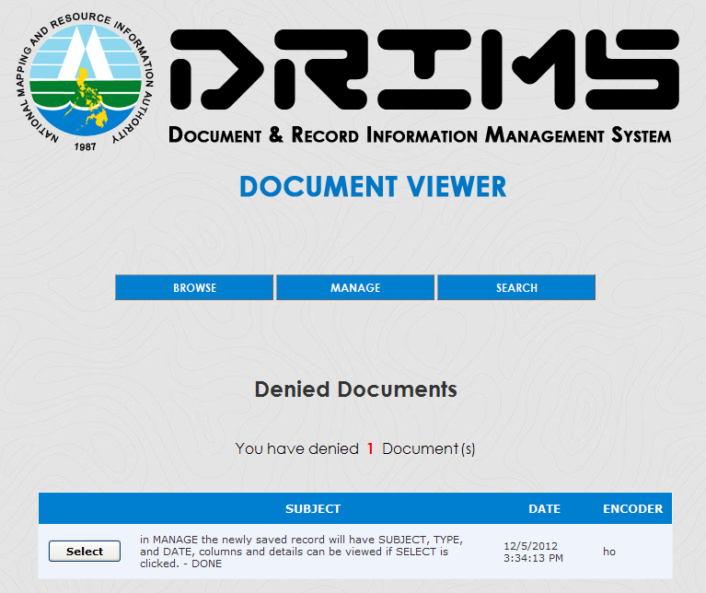

Figure 25
- Choose from the documents and click button to redirect you to the Document Details page.
- Click button if you want to approve it so that it will now be posted and can be viewed in the Document Browse page. (See Figure 7)

LOGGING OUT
To Log out in the system, click link button in the upper right of the system interface.

*Note: The system administrator’s page contains monitoring of user logs, user activity logs and the creation of the system user. The system administrator gives the Overall Document Controller (ODC) the permission to delete a document and required his/her password to continue the deletion process of document. The deleted document will appear in the Deleted Document page, a page that contains the list of the document that has been deleted by the Overall Document Controller (ODC). The deleted document can be reposted or deleted permanently in the database depending on the request of the Overall Document Controller (ODC).

